Description: EppingWestLogo_Correspondence

**Kindergarten 2021** 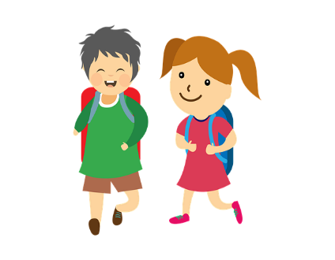

Epping West Public School will be providing a different format this year for our Kindergarten Transition Program due to COVID restrictions. We aim to provide a smooth transition for all families to suit our context.

Some of these processes are below:-

* On-line enrolment and individual family appointments allows families to come on-site to provide paperwork and ask individual questions at their appointment time.
* Families will receive an acceptance email with information regarding uniform ordering and pick-up times.
* Families will receive a second letter in the mail containing:-
* Countdown calendar – parents and students can tick off the days and do the activities provided
* A welcome Christmas card from a current Year 5 student
* Before and After School Care contact details
* Information and a code on how to book an individual Best Start appointment at the beginning of 2021- (one individual hour appointment time for each student – either – 29/1, 1/2 , 2/2 or 3/2) – parents choose one time slot
* At the Best Start Appointment students will meet a kinder teacher, see a kinder classroom, undertake the assessment, and be taken on a small tour of the main facilities of the school. Students will receive a Road Safety Bag and a Parent Guide to the NSW Primary Syllabus.
* All Kinder students will start on Thursday 4th February 2021
* All Kinder students will finish at 2:50pm in Term 1 2021
* Parents and students can access the virtual tour clips showcasing different areas of our school on the school website
* Parents can also access the Epping West website for any further information and show their children photos from our school
* Early next year parents will receive information on how their child will be dropped off on 4th February, 2021.
* Parents can talk to their children about ‘big school’ and the positive experiences we offer. Parents can consistently revise through daily routines/opportunities for the children to be independent in toileting/dressing/feeding, being confident to ask a question – ie toilet, sitting for periods of time to listen to others, sharing/ taking turns, cleaning –up after themselves etc.
* Parents are reminded not to park in the staff carpark – walking to school is preferable.

